## Merchant Name: Cocoon Implementation POC: Royce *(IM to fill)* CX POC: *[IMP to Add]*

### 

### 

| Notes Sections   *(AE to fill if they have, Implementation to be completion DRI on handoff)*   * Info on how merchant bills   **1. Historical contracts (30%)** - # of leaves - implementation  - billed monthly (arrears, upfront, retroactive)   **2. New standard contracts (70%)** - PEPM flat rate  - implementation  - discounts, payment terms  Process:  Deal closed → Accounting lead manually inputs contract info into Chargebee → CSM updates on usage (historical)   Chargebee not connected   - manual payment reconciliation - customer comes back for corrections   - currently at max capacity    - 15-20 customers/month → 30-40/month by EOY  1) What is the merchant temperament?  Lisa is super nice and very easy to work with  Courtney is external but also very nice and easy to work with  3) What are the Tabs features that the key POC cares about? |
| --- |

### Billing model *(Entire Section: Implementation to fill section)*

* Are there unique things about the customer creation process for this merchant?
* Information on how merchant bills
* How contract is broken up
* One off things to know about the merchant

### Contract Processing Steps *(Entire Section: Implementation/Success to fill Post-Go Live)*

* **General**
  + Billing email to be extracted from the contract / renewal doc? it can override what's stored at the customer level if different
  + BTs are generally found in the order form, which could be at the top of the contract or in Exhibit A
  + There will generally be an annual subscription fee and an implementation fee
  + Any time there is a renewal they will create a new doc so don't process anything related to renewals.
    - For renewal contracts, process the renewal BTs under the renewal contract.
      * [Example](https://garage.tabsplatform.com/prod/contracts/c2cd5748-66d1-4d5a-9503-c51336a91623/terms/revenue)
  + Period should be for 1 month, not the whole year, for the following:
    - Implementation Fee
    - Transfer Leaves Fee
    - Additional Entity Fee
  + Annual subscription fee is for full year period
* **Item Name:**
  + Ex. “Per Leave Fee”, “Monthly Software Fee”
* **Billing Type:**
  + Per Leave Fee and Monthly Software Fee are Unit Price BTs
    - **Event to track:**
      * Per Leave Fee = Leaves
      * Monthly Software Fee = Per Employee
    - **If there is a minimum requirement - turn on Usage AI**

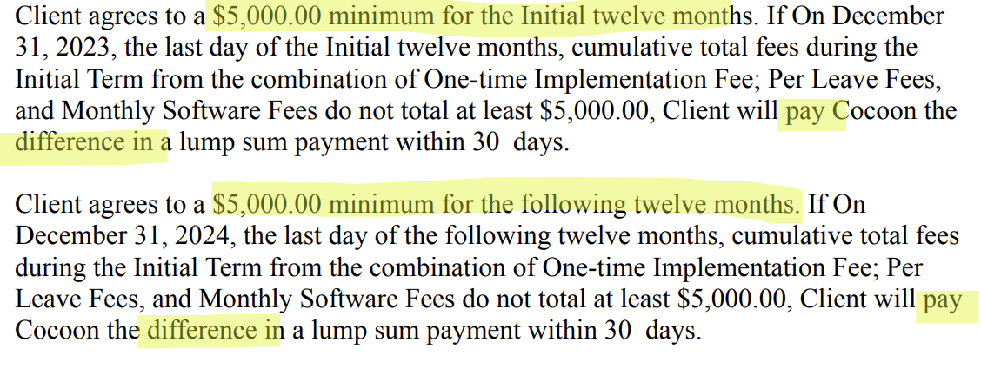

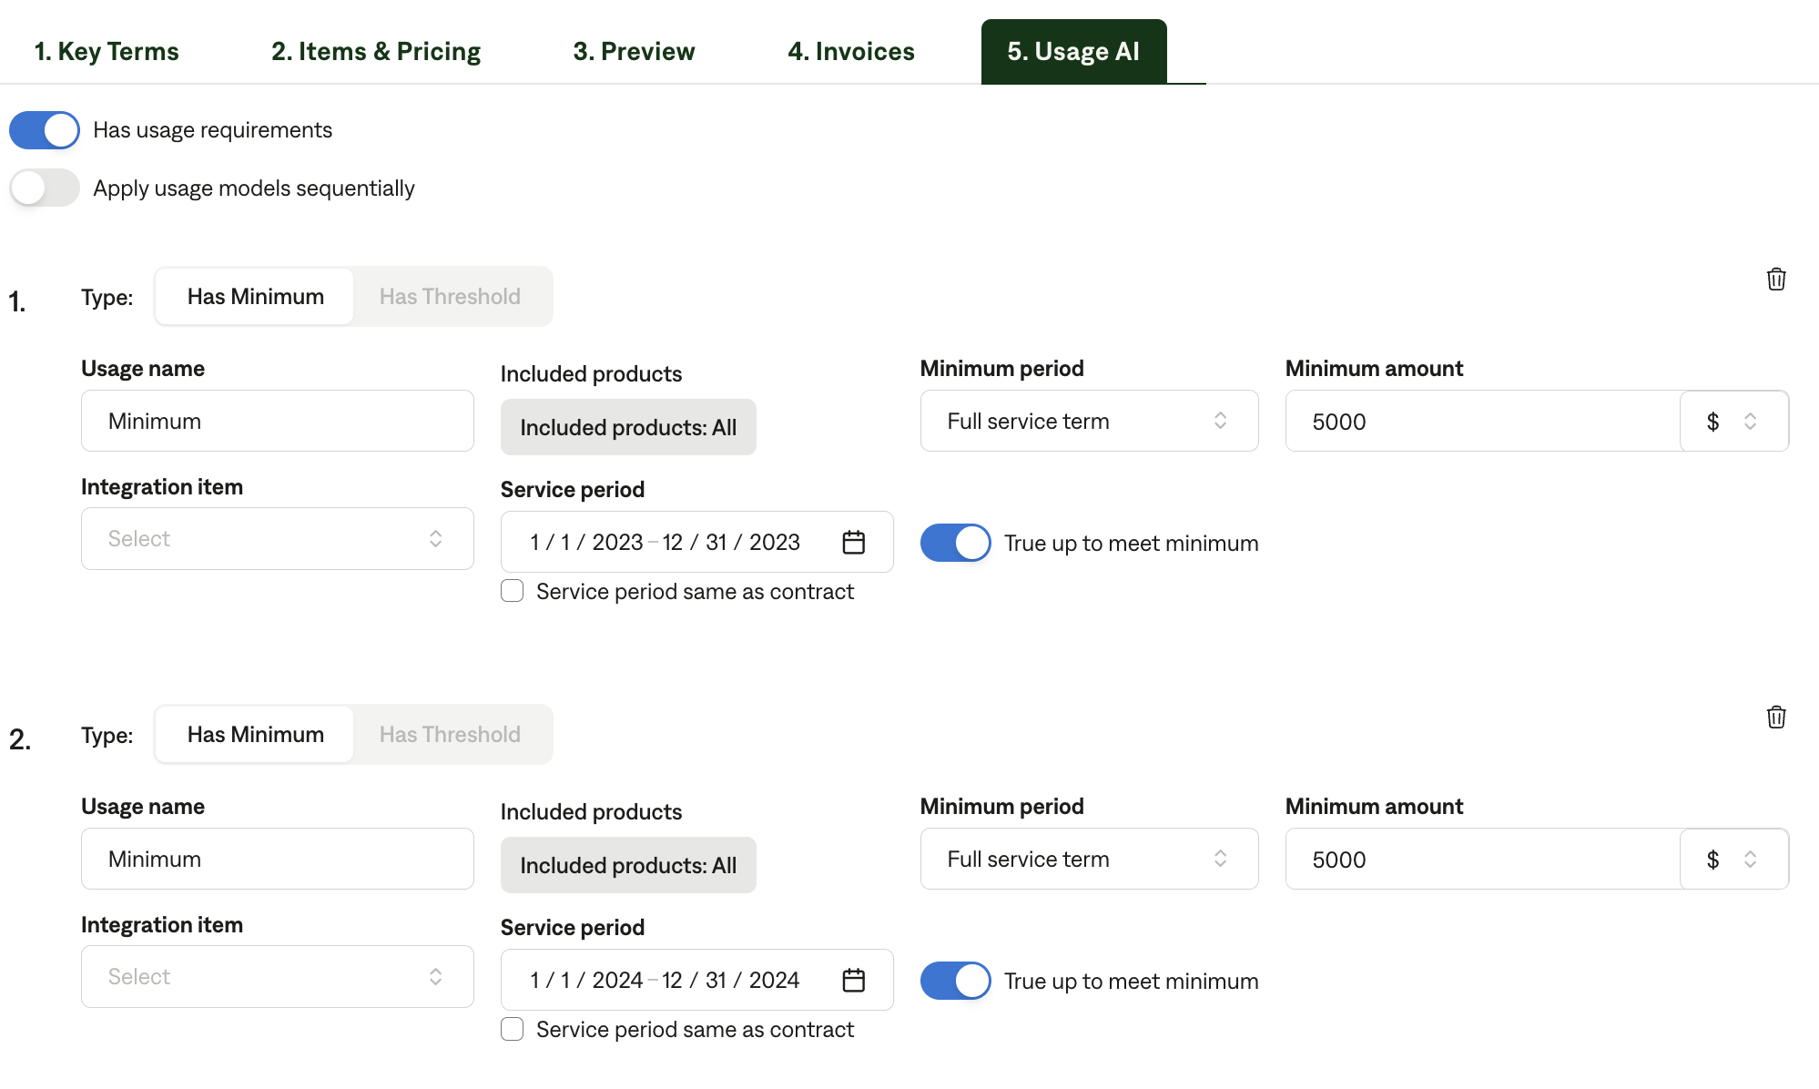

* **Service Start Date:**
  + Start date in the Services and Term section
  + IF contract has a clause like the below
    - Customer will be invoiced for $10,348.80 ***the month after the contract start date*** and every three (3) months following.
      * You would need to start the invoice on the first of the *following month* for Flat BTs - so if signed 6/23, start on 7/1
      * For the Usage BTs, you will start the BT on the *first of the signature month* - so if signed 6/23, start the usage BT 6/1 and add a month for duration
  + Will often be the “Initial Term:”
* **Billing Start Date:** same as service start date
* **Months of Service:** 
  + Use the length of the initial term for software fees
  + Use 1 month for implementation
* **Discounts:**
  + Make an in-line discount for both annual software and implementation if listed
  + Make sure to include $0 BTs
  + If a BT is “waived”, add a 100% in-line discount
  + For annual software fee, you may have to do the calculation yourself
    - For example [LINK](https://garage.tabsplatform.com/prod/contracts/0e850e45-0420-44ed-adcc-4ef0d4d2513e/preview)
      * “$6.16 PEPM x **560 US Employees** per census **x 12 months = *$41,395.20*** Total Annual Software Fee”
      * “20% discount applied to reduce PEPM fee from **$7.70 to $6.16.**”
      * Annual Software Fee total price will be **7.70 * 560 * 12 months** = ***$51,744***
      * ***51,744 - 41,395.20*** = $10,348.8 discount
      * Note: often the % discount won’t calculate correctly, so you will need to do this math to show it in-line
* **Frequency:**
  + Year for annual software BTs
  + Implementation = none
  + Set to Monthly for usage BTs if usage is invoiced monthly in arrears
* **Net Terms:**
  + Use Net 30 unless a different payment term is stated
* **Additional considerations:**
  + You DO NOT need to process any usage BTs for “Additional Employees” or additional PEPM *unless…*
    - There are multiple years of per customer fees [Example](https://garage.tabsplatform.com/prod/contracts/5f42b78c-096c-440f-9aff-28c352d2a97d/preview)
      * First year, we create a flat price BT
        + “$6.72 PEPM x 298 US Employees per census x 12 months = $24,031 Total Annual Software Fee”
      * However, for the second year, we can’t know if the customer will change the # of employees, so *we need to create a usage BT for the 2nd year*
        + Service and billing start date will be the date of the second year start
    - There is no number available to calculate a Flat BT. In this case you would just create a usage BT. [Example](https://garage.tabsplatform.com/prod/contracts/c2cd5748-66d1-4d5a-9503-c51336a91623/terms/revenue) below:
      * “$1,000.00 USD x [Number of leaves submitted during the applicable monthly billing period, as determined by the date of submission of a leave plan through the Platform]”
      * “$2.50* USD x [Number of Employees in the Territory as of the first date on which the Customer has access to the Services, & on the first of each month thereafter]”
        + [Watch out for Tier Unit BT logic and FNs *

“Note: This rate applies from 1 – 100 employees. Rates decrease to $2.00 per employee per month for 101-1,000 employees.”]

* **Processed Contracts**
  + e398024d-b70c-4399-83e6-e04cce19443a
  + 0d114800-7073-48a8-8967-cacb57c3495a

1. How do we handle taxes as a line item?
   1. If None Listed, Ops Default is every tax line item becomes a BT

### Events Processing (if necessary) *(Entire Section: Implementation/Success to fill Post-Go Live)*

* Any important information on events billing

Integration Items Processing (if necessary)  
*(Entire Section: Implementation/Success to fill Post-Go Live)*

* What are the instructions for assigning integration items?
* Example: All Statsig integrations items should be labeled as “Sales”
* Example: All “Pinata” integration items should be labeled as “Software Subscription Bundle” unless otherwise noted by Merchant

Post Processing Communications (if necessary)  
*(Entire Section: Implementation/Success to fill Post-Go Live)*

* Does the Ops Team need to notify anyone on the team re: completion of processing batches in Implementation or Active phase?
* Who needs to be notified and when?
  + Example:
    - Who: Customer Success [Azmat Aziz] needs to be notified
    - Where: Messari internal merchant channel
    - When: contracts are processed [Merchant Phase: Active]

### Customer Information *(Entire Section: Implementation/Success to fill Post-Go Live)*

* Any important information on specifics customers of this merchant
  + Special memo’s certain invoices require
  + Invoice changes due to merchant/customer relationship

### Feature Requests *(AE to fill for all requests prior to Imp handoff, Imp to fill prior to go-live/Success to fill to fill Post-Go Live)*

* FR 1
  + What is it
  + Why it's important
  + Urgency

### Merchant Calls *(AE to fill for all videos prior to Imp involvement, Imp to fill prior to go-live/Success to fill to fill Post-Go Live)*

* .
* .Demo <https://us-56595.app.gong.io/call?id=6863775313232708213&account-id=374704045599844429>
* .Hubspot scoping <https://us-56595.app.gong.io/call?id=3214368775749721243&account-id=374704045599844429>
* Partnership <https://us-56595.app.gong.io/call?id=6094306695344481553&account-id=374704045599844429>
* Implementation questions <https://us-56595.app.gong.io/call?id=217469488918329472&account-id=374704045599844429>